Agency Compensation 360 Marketing Timeline & Content
Suggested content and distribution dates
As of Oct. 15, 2025
NOTE: here is a link to the Google Doc with all your co-branded state pages and their respective URLs. Please reference these links whenever you see catalyit.com/comp360/[YOUR STATE] or catalyit.com/comp360/[YOUR ASSOCIATION ABBRV]. Sorry for any confusion around this! – https://docs.google.com/document/d/139zEfMTzFoD3D_q_ZX12EUlwziEZyA6gbQ45dKMXd_g/edit?usp=sharing
Contents
Agency Compensation 360 Marketing Timeline & Content 1
Week 1 – Aug. 18 3
Email #1 to Agency Owners/Principals 3
Social Media Post 4
Blog Article 4
Week 2 – Aug. 25 7
Email #2 from State Execs to Members 7
Social Media 8
Week 3 – Sept. 1 LAUNCH WEEK 9
Social Media 9
Social Media 9
Email #3 to Agency Owners/Principals 10
Blog Article 11
Email #4 from State Exec 12
Week 4 – Sept. 8 14
Website Pop-up 14
Email #4 to Agency Owners Principals 14
Week 5 – Sept. 15 15
Blog Article 15
Social Media 16
Email #5 to Agency Owners Principals 17
Week 6 – Sept. 22 17
Social Media 17
Email #6 to Agency Owners Principals 18
Week 7 – Sept. 29 19
Social Media 19
Email #6 to Agency Owners Principals 19
Week 8 – Oct. 6 20
Social Media 20
Blog Article 21
Email #7 to Agency Owners Principals 22
Week 9 – Oct. 13 23
Social Media 23
Email #8 to Agency Owners Principals 23
Week 10 – Oct. 20 24
Social Media 24
Email #9 to Agency Owners Principals 25
Week 11 – Oct. 27 FINAL PUSH 26
Social Media 26
Email #10 to Agency Owners Principals 27
Social Media 27
Email #11 to Agency Owners Principals 27
Email #12 to Agency Owners Principals 28

Week 1 – Aug. 18

Email #1 to Agency Owners/Principals
Audience: Primary Contacts and Principals
Date: August 20
Subject: Coming Soon: Agency Compensation 360 – Built for Independent Agents
Header: Launching September 4: Agency Compensation 360
Body:
Hi [First Name],
Something big is coming for independent insurance agencies, and we want you to be part of it.
On September 4, [insert your state association] and 37 other Big “I” state associations will launch Agency Compensation 360, the first-ever multi-state compensation survey built specifically for independent agencies.
Why does this matter to you?
Because for the first time, you’ll get access to real, independent agency-specific compensation data you can actually use.
Here’s what you’ll get if you participate:
✔ Salary and commission ranges relevant to agencies like yours
✔ Benefits, PTO, and remote work trends
✔ 2026 staffing forecasts to help you plan ahead
✔ Free access to an interactive dashboard (available in early November) to compare your agency with others by size, role, state, and region
Your participation is key.
The more agents who take the survey, the stronger and more accurate the results will be, giving all of us better insights to hire smarter, retain talent, and grow our businesses.
Mark your calendar for September 4 — you’ll receive the survey link in your inbox.
Let’s make this happen — together!

Social Media Post

Download here: https://catalyit.com/hubfs/Comp360/Social%20Media/Agency%20Comp360_Teaser.jpg
Post Date: August 20
Text:
Two weeks until launch!
Agency Compensation 360 is coming September 4 — and it’s your chance to get exclusive, independent agency-specific salary, benefits, and commission data.
- Compare with agencies of similar size and location
- Make smarter hiring, retention, and budget decisions
- Get insights you can’t find anywhere else
The more agents who take the survey, the better the results for everyone!
#IndependentAgent #AgencyCompensation360 #InsuranceAgents #BigI

Blog Article
https://www.iiat.org/texas-agent-news/get-ready-agency-compensation-360-launches-september-4-we-need-your-input
Date: Aug. 20
Get Ready: Agency Compensation 360 Launches September 4 – And We Need Your Input!
Something big is coming to the independent insurance world this September, and you’re going to want in on it.
On September 4, we’re launching Agency Compensation 360, the first-ever, multi-state compensation survey built specifically for independent insurance agencies and powered by Big “I” associations. This isn’t just another generic industry report – it’s your chance to get real, independent agency-specific salary, benefits, and commission data that you can actually use.
Why this is a game changer for independent agents
Let’s be honest, up until now, getting accurate compensation data for independent agencies has been tough. Most of what’s out there mashes all kinds of insurance data together, making it hard to figure out how you really stack up.
With Agency Compensation 360, that changes. You’ll be able to compare your agency’s numbers with others of similar size and location, giving you a clear, accurate view of where you stand. Want to know how agencies your size in your region are paying producers? Or how benefits and PTO compare? You’ll finally have answers.
And the best part? If you take the survey, you get free access to the interactive dashboard when results go live in early November. You can filter the data by state, region, agency size, role, and more to get exactly the insights you need.
What’s in it for you
By participating, you’ll get:
- Salary & commission ranges that are actually relevant to independent agencies
- Benefits & PTO trends that show what’s competitive right now
- Insights into remote work adoption
- A peek at 2026 staffing forecasts so you can plan ahead
We can’t do it without you!
Here’s the thing – the more agents who take the survey, the more powerful and accurate the results will be. Your input will help create a more robust, insightful Agency Compensation 360 dashboard that benefits you and the entire independent agency community.
September 4 is compensation survey day. Look for more details in your inbox from [insert your state association] on how to complete the Agency Compensation 360 survey to access the results dashboard in November.
This is your opportunity to shape the data, see where see where your agency stands, and make smarter decisions for your business. Don’t miss it.
Launch Date: September 4
Results Available: Early November

Week 2 – Aug. 25

Email #2 from State Execs to Members
IIAT version
Audience: Agency Principals
Date: Aug. 27
Subject: What You Need to Know About Compensation 360
Body:
A First for Independent Agents — Launching Sept. 4th
[First Name],
For the first time, independent insurance agencies will have access to real compensation insights that matter.
On September 4, [YOUR STATE] and Catalyit are launching Agency Compensation 360, the first-ever multi-state compensation survey built just for independent agencies. Learn more. [link to catalyit.com/comp360/[YOUR ASSOCIATION ABBRV]
Here’s what you’ll get when you participate:
- A clear look at salaries, commissions, and benefits from agencies like yours
- Benchmarking by size and location
- Free access to an exclusive, interactive dashboard with results in November
We need your input. The more agents who participate, the stronger and more valuable the results will be — for your agency and for our entire independent agent community.
Join the Informational Webinar
On September 9 at 1 PM CT, register to attend Agency Compensation 360: What Agents Need to Know. You’ll get the full scoop on how the survey works and why it’s a must for your agency.
REGISTER NOW LINK
Sincerely,
[State Exec Name]

Social Media
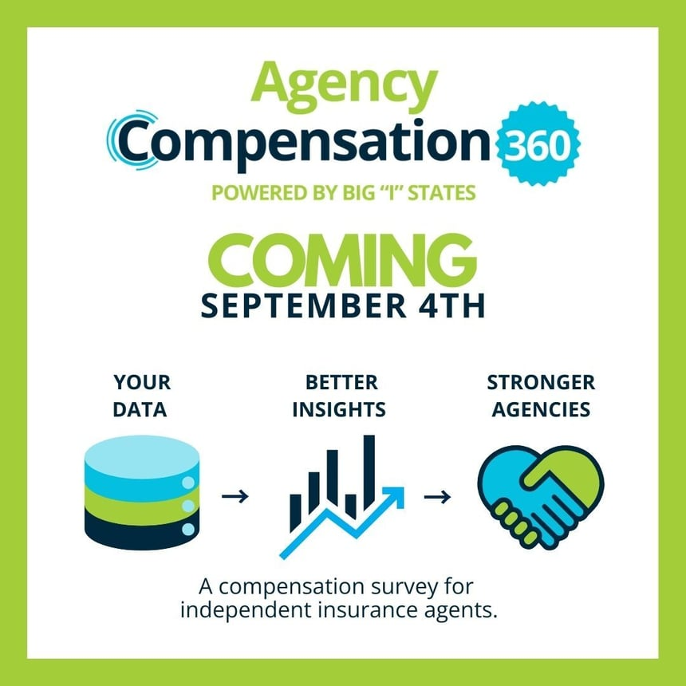
Download here: https://catalyit.com/hubfs/Comp360/Social%20Media/Agency%20Comp%20360_%232_Aug%2028.jpg
Date: Aug. 28
Text:
One week to go! Agency Compensation 360 launches September 4 — and we need YOUR voice.
The more agents who complete the survey, the more accurate and valuable the results will be.
Your data → Better insights → Stronger agencies.
💡 Mark your calendar and watch for the survey link next week.
#IndependentAgent #AgencyCompensation360 #InsuranceAgents #BigI

Week 3 – Sept. 1 LAUNCH WEEK

Social Media
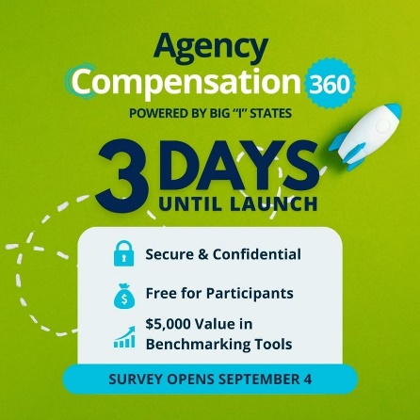
Download here:
https://catalyit.com/hubfs/Comp360/Social%20Media/Agency%20Comp%20360_Sept%201.jpg
Date: Sept. 1
Text:
3 days until launch!
This is your chance to finally see how your agency’s pay, benefits, and staffing stack up against similar agencies in your state and region.
- Secure, confidential
- Exclusive for participants
- Valuable benchmarking tools
Survey opens Sept. 4.
#IndependentAgent #AgencyCompensation360 #InsuranceAgents #BigI

Social Media
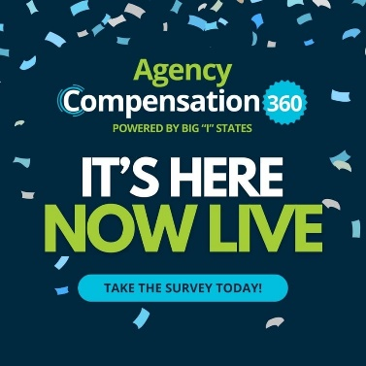
Download here:
https://catalyit.com/hubfs/Comp360/Social%20Media/Agency%20Comp%20360_Sept%204_Now%20LIVE.jpg
Date: Sept. 4
Text:
It’s here! Agency Compensation 360 is LIVE.
Take the survey today and get access to the results dashboard in November.
- Insights by size, state, and region
- Actionable tools to compete smarter and hire better
- The more agents who participate, the more powerful the results.
Are you an agency principal? Take the Survey Now – catalyit.com/comp360/[YOUR STATE]
#IndependentAgent #AgencyCompensation360 #InsuranceAgents #BigI

Email #3 to Agency Owners/Principals
Date: Sept. 4
Subject: It’s Here: Take the Agency Compensation 360 Survey Today
Header: Agency Compensation 360 is Live!
Body:
Hi [First Name],
Today’s the day! The Agency Compensation 360 survey is officially open — and we need your input.
For the first time, independent insurance agencies like yours can access real, agency-specific compensation data. This isn’t a generic industry report. It’s built exclusively for independent agents, by independent agents.
Why take the survey?
✔ Compare salaries, benefits, and commissions with agencies of similar size and location
✔ See how your compensation packages stack up in today’s market
✔ Gain insights on benefits, PTO, remote work, and staffing forecasts
✔ Get exclusive access to the interactive dashboard when results launch in early November
Your voice matters.
The more agencies that participate, the stronger and more accurate the insights will be — for your agency and for the entire independent agent community.
[Take the Survey Now – catalyit.com/comp360/[YOUR STATE]
Learn more about Agency Compensation 360 by attending an informational webinar on September 9th. REGISTER NOW LINK

Blog Article
Date: Sept 5
Agency Compensation 360 Is Live – Take the Survey Today!
The wait is over! Agency Compensation 360, a first-of-its-kind, multi-state compensation survey built exclusively for independent insurance agencies, is officially live. And here’s the bottom line: if you don’t participate, you won’t get access to the results.
Why You Should Take the Survey
By completing the survey, you’ll get EXCLUSIVE access to an interactive dashboard when results are released in early November.
That dashboard will give you:
- A clear view of salary and commission ranges
- Benchmarking for benefits, PTO, and remote work trends
- Insights into 2026 staffing forecasts
- Filters by state, region, agency size, and role so you can see exactly how your agency compares
Your Participation Is the Key
Every response helps build a stronger, more reliable data set that benefits the entire independent agency community.
But here’s the catch: Only participating agencies get access to the results.
The survey closes November 2, and the dashboard will be available later that month. Don’t wait until it’s too late.
Are you an agency principal? Complete the survey to get the results in November.
Take the Survey– catalyit.com/comp360/[YOUR STATE]
This is your opportunity to see where your agency stands and use real data to make better decisions about hiring, retention, and growth.
Learn more about Agency Compensation 360 by attending an informational webinar on September 9th. REGISTER NOW LINK

Email #4 from State Exec
Audience: Agency Principals
Date: Sept. 6
Subject: It’s Here – Take the Agency Compensation 360 Survey Today
Body:
Hi [First Name],
The Agency Compensation 360 survey is officially live — and we need your voice.
For the first time, independent insurance agencies like yours can get real, agency-specific salary, benefits, and commission data you can actually use. As a YOUR STATE member, you get exclusive access to the Agency Compensation 360 dashboard in November, but only if you complete the survey.
- Compare with agencies of similar size and location
- Access an exclusive interactive results dashboard — free for participants
- Use the insights to compete smarter, hire faster, and keep top talent
The more agents who take the survey, the stronger and more valuable the results will be for everyone. As a member
Take the survey now and make your agency’s data count.
Take the Survey– catalyit.com/comp360/YOUR STATE]
Sincerely,
[State Exec Name]

Week 4 – Sept. 8

Website Pop-up
IIAT version/example
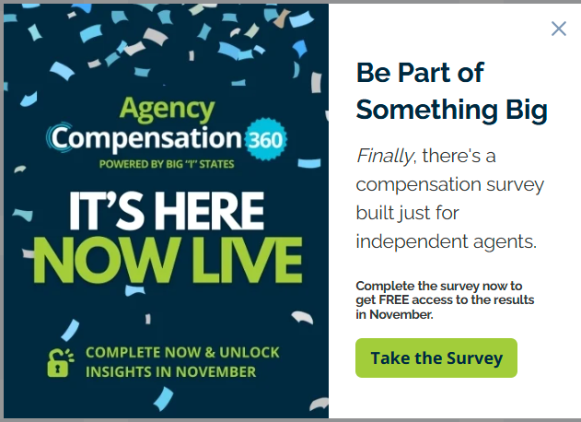
Date Sept. 8
Audience: Agency Principals
Be Part of Something Big
Finally, there’s a compensation survey built just for independent agents. Complete the Agency Compensation 360 survey now and unlock insights in November.
Take the Survey – catalyit.com/comp360/[YOUR ASSOCIATION ABBRV]

Email #4 to Agency Owners Principals
Date: Sept. 11
Subject line: End the FOMO. Take the Comp Survey to get the Results
The survey has been live for one week. Don’t miss out on securing your results.
Hi [First Name],
The Agency Compensation 360 survey has been live for just one week — and agencies across YOUR STATE are already completing it to lock in their access to the results dashboard this November.
Don’t miss your chance to be counted. Complete the survey today and secure your exclusive dashboard access.
Take the Survey Today – catalyit.com/comp360/[YOUR ASSOCIATION ABBRV]
[Watch Now]
Agency Compensation 360: What Agents Should Know https://catalyit.com/techtips/agency-compensation-360-what-agency-leaders-should-know
Watch the webinar to hear why Agency Compensation 360 is a game-changer and what agency leaders can expect when they participate.

Week 5 – Sept. 15

Blog Article
Date: Sept. 16
Agency Compensation 360: What Agency Leaders Should Know
https://catalyit.com/techtips/agency-compensation-360-what-agency-leaders-should-know

Social Media
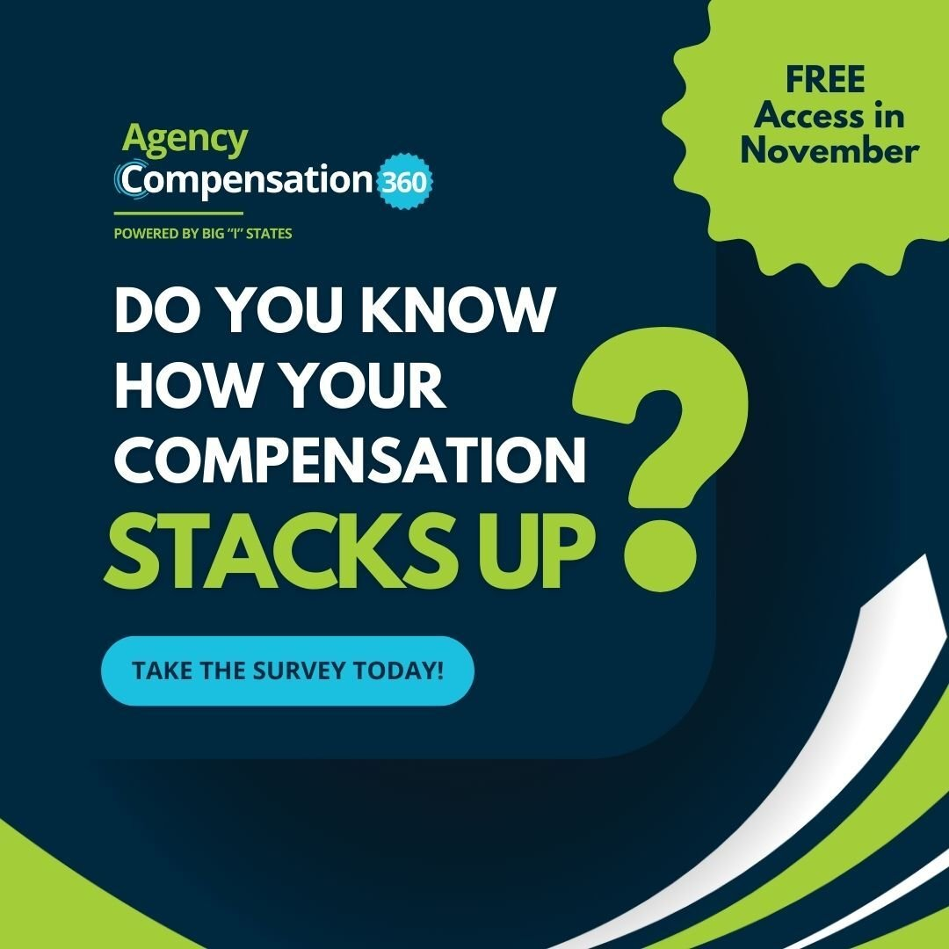
Download here: https://catalyit.com/hubfs/Comp360/Social%20Media/Sept.%2017_How%20does%20your%20agency%20stack%20up.jpg
Date Sept. 17
Do you know how your compensation stacks up?
With Agency Compensation 360, you don’t have to guess.
Benchmark your pay, benefits, and staffing against similar agencies and stay competitive in today’s talent market.
Results available in early November — but only for agencies that participate.
Take the survey today and unlock the insights dashboard free: [Survey Link]
#AgencyComp360 #InsuranceAgents
catalyit.com/comp360/[YOUR ASSOCIATION ABBRV]
#AgencyComp360 #IndependentAgent #BigI

Email #5 to Agency Owners Principals
Date: Sept. 18
Subject line: The more who participate, the stronger the data
Every response makes the dashboard more valuable. Add your agency’s voice.
Hi [First Name],
The more independent agencies that participate, the stronger and more accurate the results will be. Your input helps create the most powerful compensation resource for agents in YOUR STATE — and across the country.
Be part of it. Complete the survey today and gain free access to the interactive dashboard in November.
Complete the Survey – catalyit.com/comp360/[YOUR ASSOCIATION ABBRV]

Week 6 – Sept. 22

Social Media
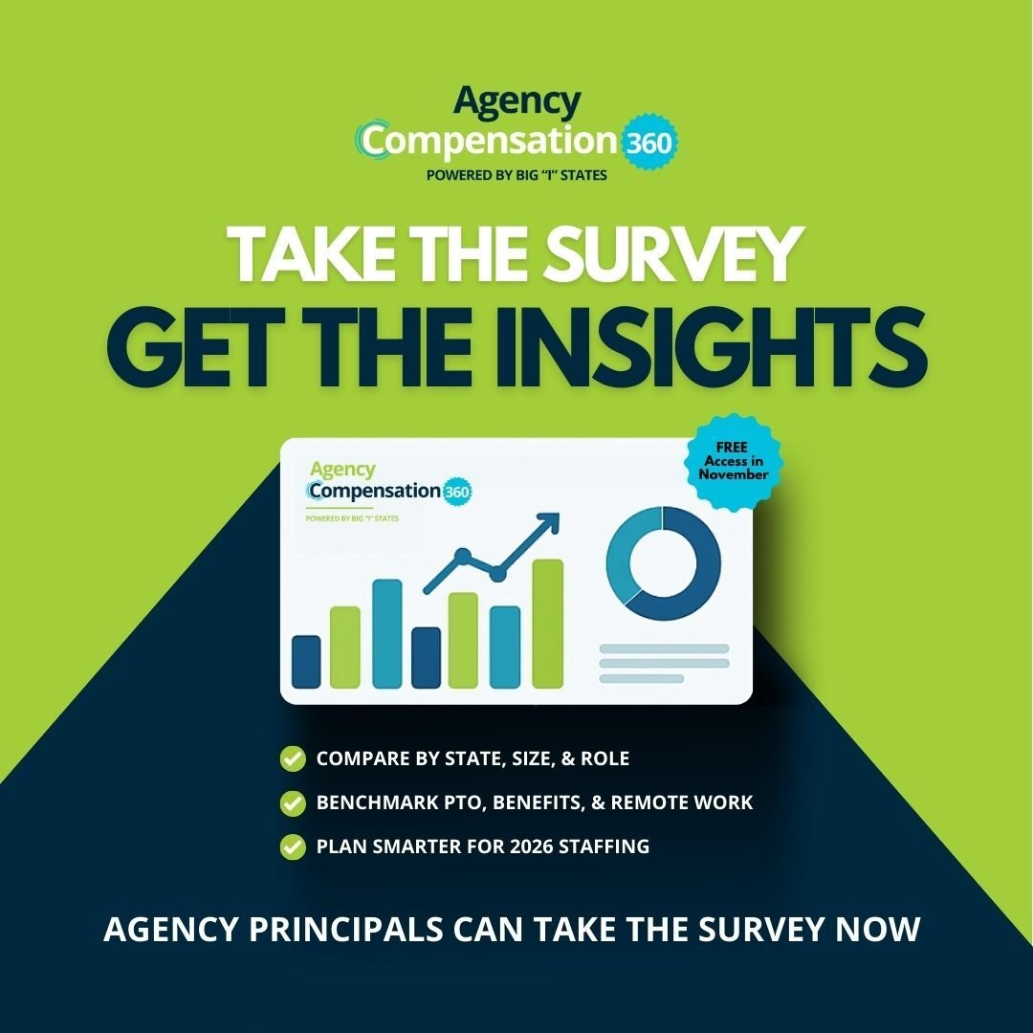
Download here:
https://catalyit.com/hubfs/Comp360/Social%20Media/Sept.%2023_Get%20Insights.jpg
Date: Sept. 23
Take the survey. Get the insights.
When you complete Agency Compensation 360, you’ll unlock free access to an interactive dashboard when results go live in November.
✔ Compare by state, size, and role
✔ Benchmark PTO, benefits, and remote work
✔ Plan smarter for 2026 staffing
Take the survey now: catalyit.com/comp360/[YOUR ASSOCIATION ABBRV]
#AgencyComp360 #IndependentAgent

Email #6 to Agency Owners Principals
Date: Sept. 25
Subject line: See how your agency really stacks up
Benchmark compensation with agencies of similar size and location.
Hi [First Name],
Do you know how your agency’s pay and benefits compare to others? With Agency Compensation 360, you’ll finally get real, agency-specific data you can trust.
Benchmark by agency size, role, and location — and use the insights to stay competitive in today’s talent market.
Don’t wait. Complete the survey today.
Take the Survey Today – catalyit.com/comp360/[YOUR ASSOCIATION ABBRV]

Week 7 – Sept. 29

Social Media
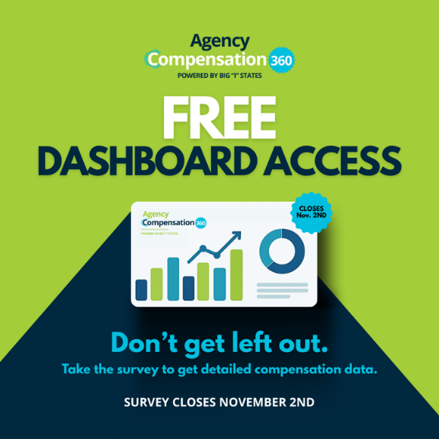
Download here:
https://catalyit.com/hubfs/Comp360/Social%20Media/Sept.%2030_Don't%20Get%20Left%20Out.png
Date Sept. 30
Don’t get left out.
If you don’t complete the Agency Compensation 360 survey by Nov. 2, your agency will miss the chance to access the interactive results dashboard for free.
Only participating agencies get the insights:
- Salaries & commissions
- Benefits & PTO
- Remote work & staffing forecasts
Don’t miss your chance to see how your agency really stacks up.
Take the Survey Today – catalyit.com/comp360/[YOUR ASSOCIATION ABBRV]
#IndependentAgent #AgencyComp360 #InsuranceAgents #BigI

Email #6 to Agency Owners Principals
Date: Oct. 2
Subject line: A compensation dashboard — free when you participate
Only agents who complete the survey get access to the results.
Hi [First Name],
When you complete the Agency Compensation 360 survey, you’ll unlock free access to an interactive results dashboard when it goes live in early November.
Filter by state, region, size, and role to see exactly how your agency compares.
But remember: only participants get access.
Secure My Access Now – catalyit.com/comp360/[YOUR ASSOCIATION ABBRV]

Week 8 – Oct. 6

Social Media

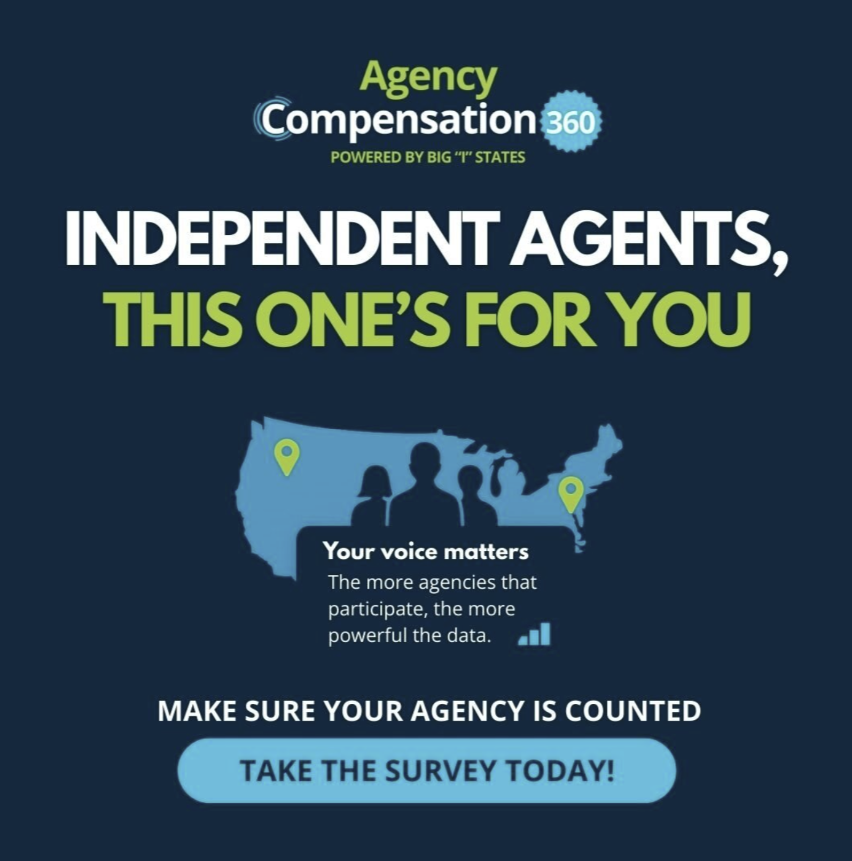
Download here: https://46515599.fs1.hubspotusercontent-na1.net/hubfs/46515599/Comp360/Social%20Media/Oct.%207.jpg
Date: Oct. 7
Independent agents, this one’s for YOU.
The Agency Compensation 360 survey is powered by Big “I” states and built to give independent agencies the data we’ve been missing.
Your voice matters — the more agencies that take the survey, the more valuable the dashboard will be.
Make sure your agency is counted.
Take the Survey Now – catalyit.com/comp360/[YOUR ASSOCIATION ABBRV]

Blog Article
Date: Oct. 8
Why STATE Independent Agencies Need Their Own Compensation Study
For years, independent insurance agencies in STATE have had to rely on generic compensation surveys that don’t reflect the unique size, structure, and realities of our industry. Until now, there has never been a comprehensive compensation survey designed exclusively for independent agents across STATE.
That’s why Agency Compensation 360 [LINK TO YOUR CO-BRANDED COMP360 PAGE] was created. It's an industry-wide initiative to collect accurate, STATE-specific compensation data from independent agencies of every size and type.
Why a STATE-Specific Compensation Survey Matters
Independent agencies in STATE span everything from small-town, family-run shops to large, multi-location firms. National or generalized compensation data can’t capture that diversity, leaving owners without reliable benchmarks.
Accurate compensation data matters because it helps you:
- Attract and retain top talent: Competitive pay structures ensure you’re not losing employees to competitors.
- Make smarter business decisions: Reliable benchmarks give you confidence in budgeting, hiring, and growth planning.
- Strengthen your agency’s future: Aligning compensation with industry standards protects your agency from turnover and helps sustain profitability.
The Opportunity Is Now
The Agency Compensation 360 [LINK TO YOUR CO-BRANDED COMP360 PAGE] survey is live right now, and we need participation from independent agency owners across STATE. The more agencies that complete the survey, the stronger and more accurate the results will be.
But here’s the catch: Only agency owners and principals who complete the survey by November 2 will gain access to the interactive results dashboard in November. This tool will allow you to see compensation trends across agencies in STATE – finally giving you the data you need to make confident decisions.
Don’t Miss Out
Independent agents have never had access to this kind of STATE-focused compensation data before. Don’t be left in the dark while your peers gain insights that could reshape their compensation strategy.
Start the Survey – catalyit.com/comp360/[YOUR ASSOCIATION ABBRV]

Email #7 to Agency Owners Principals
Date: Oct. 9
Subject line: Use real data to plan for 2025
Dashboard results available in November — right in time for year-end planning.
Hi [First Name],
Raises. Hiring. Benefits. Staffing plans. All are easier when you’ve got real data, not guesses.
Complete the Agency Compensation 360 survey today and unlock your free dashboard in November — just in time for 2025 planning.
Don’t miss your chance to use real insights to guide smarter decisions.
Take the Survey Before It’s Too Late – catalyit.com/comp360/[YOUR ASSOCIATION ABBRV]

Week 9 – Oct. 13

Social Media
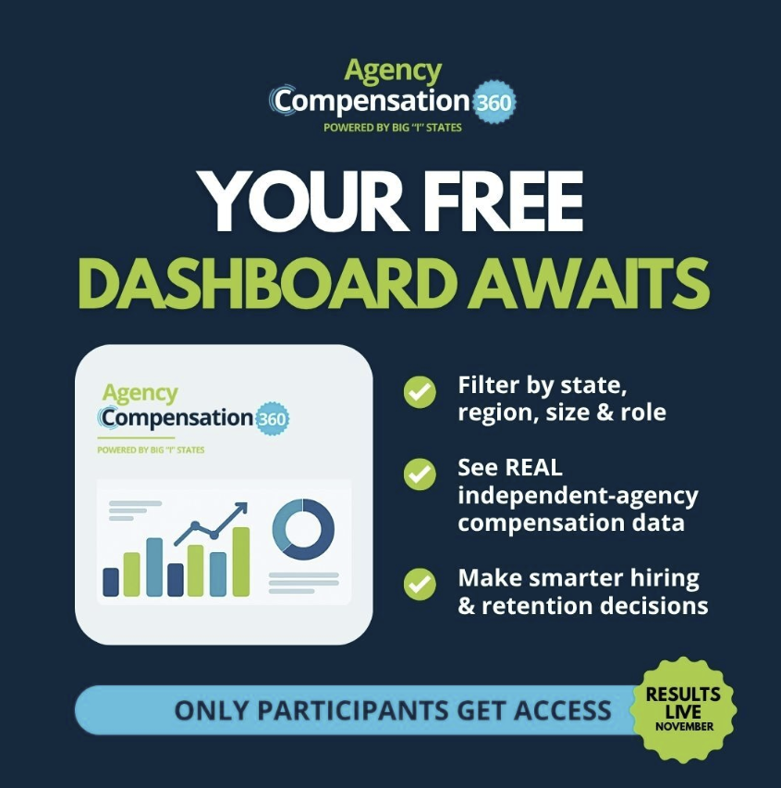
Download here: https://catalyit.com/hubfs/Comp360/Social%20Media/Oct.%2014.jpg
Oct. Oct. 14
Agencies that complete Agency Compensation 360 will get free access to this powerful dashboard in November.
- Filter by state, region, size, and role
- See real, independent-agency compensation data
- Make smarter hiring and retention decisions
Don’t miss out — only participants get access!
Take the Survey Today – catalyit.com/comp360/[YOUR ASSOCIATION ABBRV]

Email #8 to Agency Owners Principals
Date: Oct. 16
Subject line: The Agency Compensation Survey closes in just 2 weeks
Time is running out. Don’t lose your chance to be counted and see the data.
Hi [First Name],
The Agency Compensation 360 survey closes in just two weeks.
If you haven’t completed it yet, now’s the time. Only participating agencies get access to the results dashboard in November.
Don’t miss out.
Take the Survey Today – catalyit.com/comp360/[YOUR ASSOCIATION ABBRV]

Week 10 – Oct. 20

Social Media
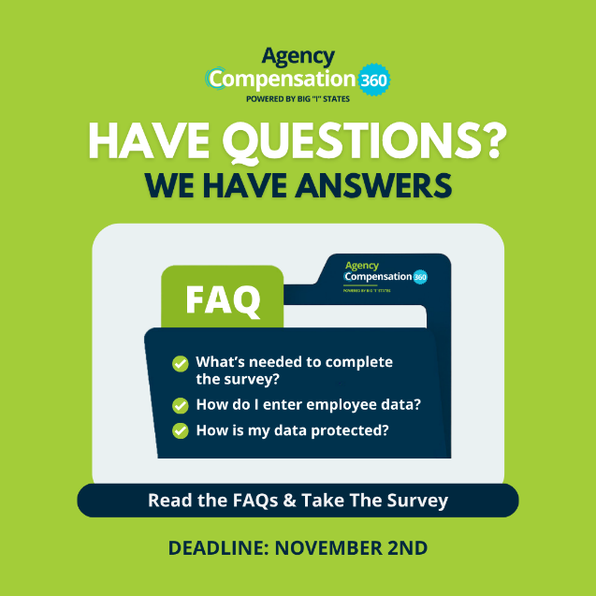
Download here: https://catalyit.com/hubfs/Comp360/Social%20Media/Oct.%2021.png
Date: Oct. 21
Our new FAQ article covers everything you need to know before completing the survey—what questions to expect, how to input employee data, who can participate, and how your data is protected.
Completing the survey takes about one hour, and participating agencies will gain exclusive access to the interactive results dashboard in November.
Don’t wait—get the answers, complete your survey, and help shape the future of compensation data for independent agencies in STATE.
Read the FAQs [Insert Link - https://catalyit.com/techtips/top-questions-from-agency-owners-about-completing-the-agency-compensation-360-study]
Take the Survey Today – catalyit.com/comp360/[YOUR ASSOCIATION ABBRV]
Deadline: November 2

Email #9 to Agency Owners Principals
Date: Oct. 23
Subject Line: Your top questions about the Agency Compensation 360 Study—answered
Hi [First Name],
There’s still time to complete the Agency Compensation 360 Survey, but the deadline is November 2, and you won’t want to miss out on the results.
We’ve published a quick FAQ article answering the top questions from agency owners, including:
- What types of questions you’ll be asked
- How to input employee data
- How your information stays private and secure
Completing the survey takes about 30 minutes, and it’s one of the smartest investments you can make this year. Agencies that finish by November 2 will receive exclusive access to the interactive results dashboard—your insider look at STATE agency compensation trends.
Read the FAQs [Insert Link - https://catalyit.com/techtips/top-questions-from-agency-owners-about-completing-the-agency-compensation-360-study]
Take the Survey Now – catalyit.com/comp360/[YOUR ASSOCIATION ABBRV]
Make sure your agency’s data is part of the story.

Week 11 – Oct. 27 FINAL PUSH

Social Media
Oct. 28
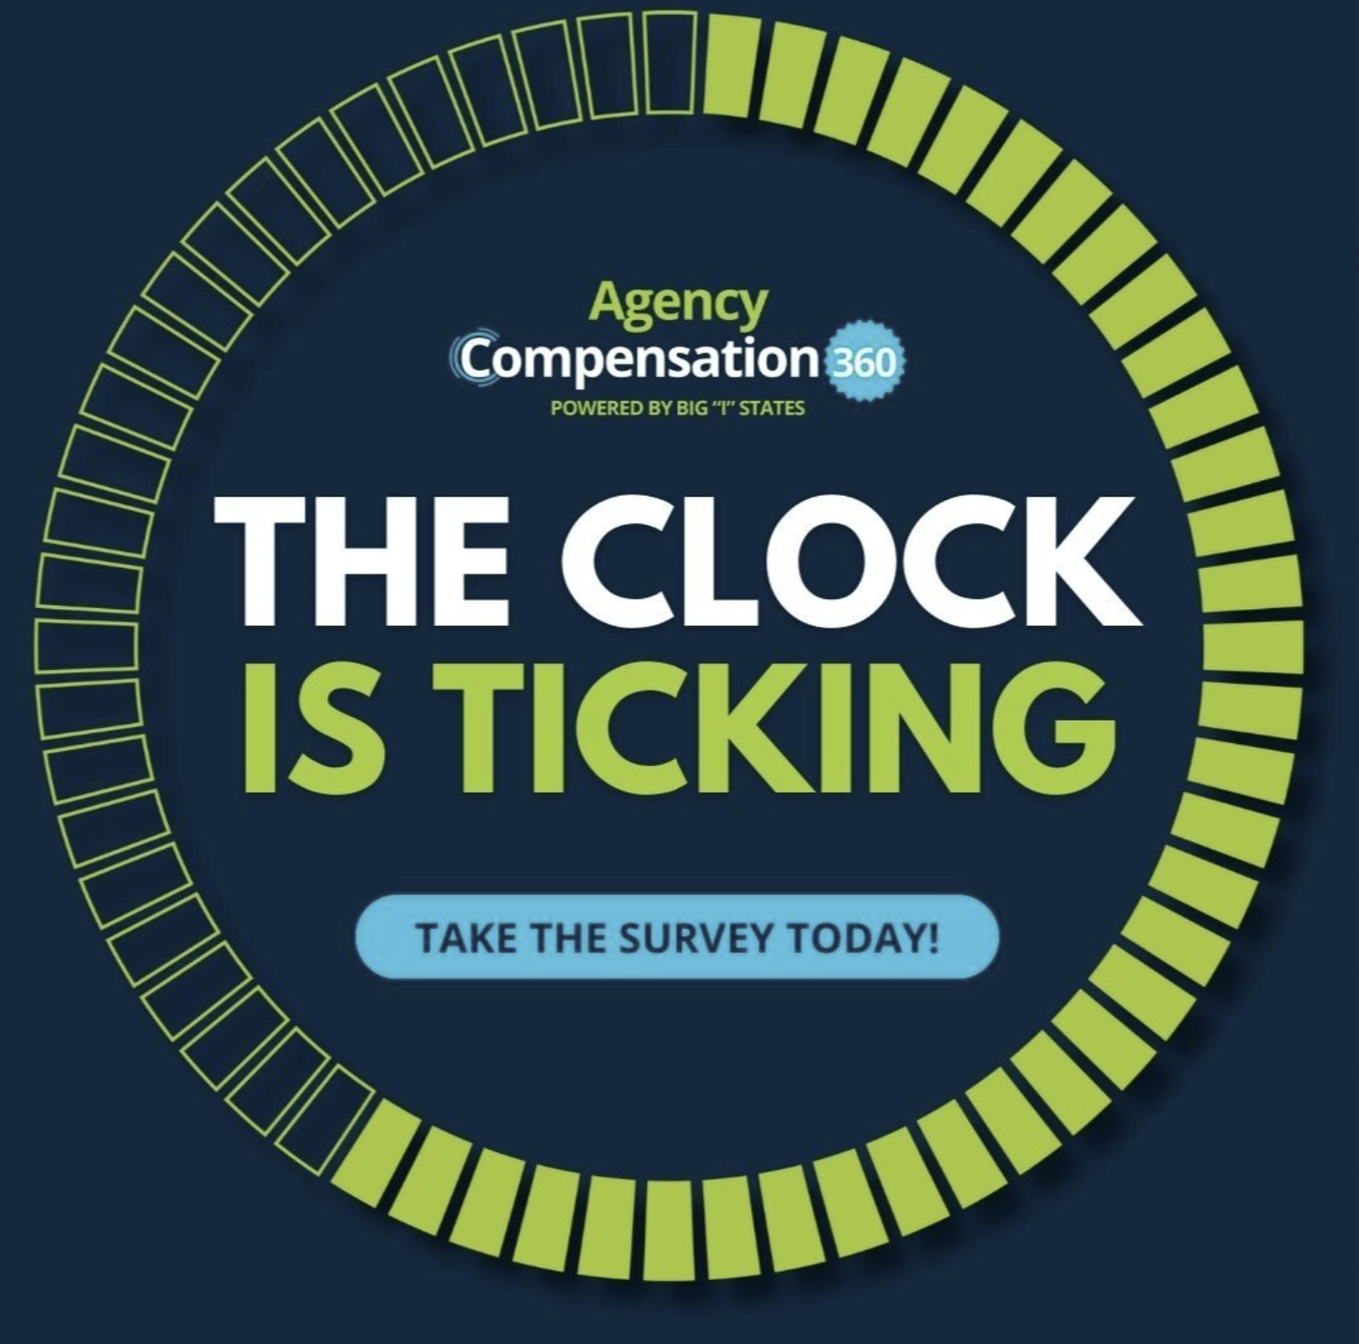
Download here: https://catalyit.com/hubfs/Comp360/Social%20Media/Oct.%2028.jpg
The Agency Compensation 360 survey closes Nov. 2nd!
Don’t get left out. If you’re an agency owner or principal, complete the survey now to lock in your free dashboard access.
Don’t miss out on:
✔ Salary & commission benchmarking
✔ PTO & benefits trends
✔ Remote work insights
✔ 2026 staffing forecasts
All included in an interactive dashboard — free for participants.
But only if you complete the survey by Nov. 2!
catalyit.com/comp360/[YOUR ASSOCIATION ABBRV]
#AgencyComp360 #InsuranceAgents

Email #10 to Agency Owners Principals
Date: Oct. 29
Subject line: Closes in 3 days — take the survey now
Last call to participate before the Nov. 2 deadline.
Hi [First Name],
The Agency Compensation 360 survey closes in just 3 days.
This is your last chance to complete it and secure your dashboard access in November.
Don’t wait. Make your agency’s data count.
Take the Survey Now – catalyit.com/comp360/[YOUR ASSOCIATION ABBRV]

Social Media
Date: Nov. 1
🚨 LAST CHANCE 🚨
The Agency Compensation 360 survey closes tomorrow, Nov. 2!
This is your final opportunity to be counted — and to unlock your free access to the results dashboard in November.
Don’t wait. Make your agency’s data count.
Take the survey now: catalyit.com/comp360/[YOUR ASSOCIATION ABBRV]

Email #11 to Agency Owners Principals
Date: Nov. 1 – Final Call
Subject line: Tomorrow is the deadline — don’t miss out
Tomorrow is the final day to participate in Agency Compensation 360.
Hi [First Name],
Tomorrow is your last chance to be counted in Agency Compensation 360.
If you don’t complete the survey, you won’t get access to the results dashboard when it’s released in November.
[Submit My Survey Before It Closes] catalyit.com/comp360/[YOUR ASSOCIATION ABBRV]

Email #12 to Agency Owners Principals
Date: Nov. 2 – Closing Day
Subject line: Survey closes tonight — last chance to be counted
Midnight is the deadline. Take the survey now.
Hi [First Name],
This is it — the Agency Compensation 360 survey closes tonight at midnight.
Don’t miss your last chance to complete the survey and unlock your exclusive results dashboard in November.
[Take the Survey Before Midnight] catalyit.com/comp360/[YOUR ASSOCIATION ABBRV]

